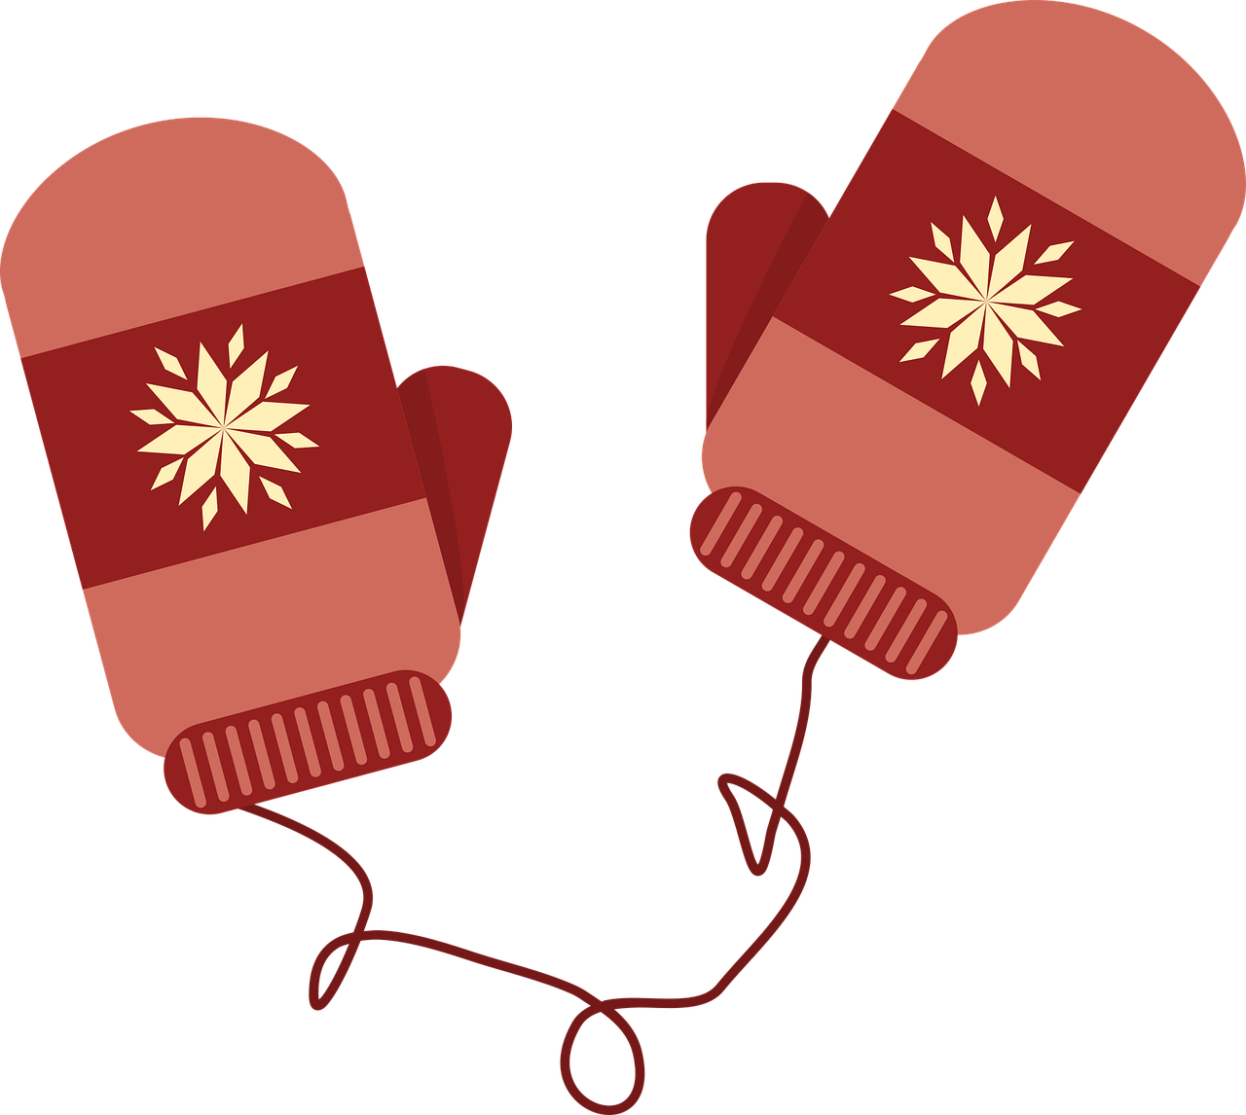 |  | 1  Small Friends  Closed  Holiday Break | 2  Small Friends  Closed  Holiday Break | 3  Small Friends  Closed  Holiday Break
6  AM: Cheerios and Milk or Cereal Bar  PM: Banana or Goldfish | 7  AM: Rice Krispies and Milk or Cereal Bar  PM: Animal Crackers or Banana | 8  AM: Cornflakes and Milk or Cereal Bar  PM: Oyster Crackers or Banana | 9  AM: Rice Krispies and Milk or Cereal Bar  PM: Banana or Animal Crackers | 10  AM: Chex and Milk or Banana  PM: Goldfish or Oyster Crackers
13  AM: Chex and Milk or Cereal Bar  PM: Goldfish or Animal Crackers | 14  AM: Cornflakes and Milk or Cereal Bar  PM: Oyster Crackers or Goldfish | 15  AM: Rice Krispies and Milk or Cereal Bar  PM: Oyster Crackers or Animal Crackers | 16  AM: Kix and Milk or Cereal Bar  PM: Goldfish or Oyster Crackers | 17  AM: Cheerios and Milk or Cereal Bar  PM: Animal Crackers or Goldfish
20  Small Friends  Closed  Martin Luther King  Day | 21  AM: Rice Krispies and Milk or Cereal Bar  PM: Goldfish or Oyster Crackers | 22  AM: Chex and Milk or Cereal Bar  PM: Animal Crackers or Goldfish | 23  AM: Cheerios and Milk or Cereal Bar  PM: Oyster Crackers or Animal Crackers | 24  AM: Cornflakes and Milk or Cereal Bar  PM: Goldfish or Animal Crackers
27  AM: Rice Krispies and Milk or Cereal Bar  PM: Banana or Goldfish | 28  AM: Cornflakes and Milk or Cereal Bar  PM: Banana or Animal Crackers | 29  AM: Cheerios and Milk or Banana  PM: Cereal Bar or Oyster Crackers | 30  AM: Rice Krispies and Milk or Banana  PM: Animal Crackers or Cereal Bar | 31  AM: Chex and Milk or Cereal Bar  PM: Banana or Goldfish

